Lenovo

[Email address]

Abstract

THIS PROJECT HELPS IN MAMNAGING THE ON-GOING AND UPCOMING EVENTS IN AN ORGANIZATION.

build AN EVENT MANAGEMENT SYSTEM USING SALESFORCE

BUILT AN EVNT MANAGEMENT SYSTEM USING SALESFORCE

INRTODUCTION

1.1 OVERVEIW :

**Event management is the process of creating and maintaining an event. This process spans from the very beginning of planning all the way to post-event strategizing.**

**At the start, an event manager makes planning decisions, such as the time, location, and theme of their event. During an event, event managers oversee the event live and make sure things run smoothly. After an event, event managers are tasked with reviewing event data, submitting KPI and ROI findings, and staying on the ball for any post-event offerings.**

**All different branches of planning go into event management, including various types of sourcing, designing, regulation checks, and on-site management. In event management, you could be in the process of creating a conference, a product launch, an internal sales kick-off, or even a wedding. Really, any event that requires considerable planning and execution is event management.**

DISTINCT FEATURES:

* Digital Venue. In the age of virtual and hybrid events, teams still need to deliver unique and engaging experiences. ...
* Custom-branded Mobile App. During your event, attendees have a lot on their minds. ...
* Chat Channels. The best events are interactive. ...

2. problem definition and design thinking.

2.1 empathy map

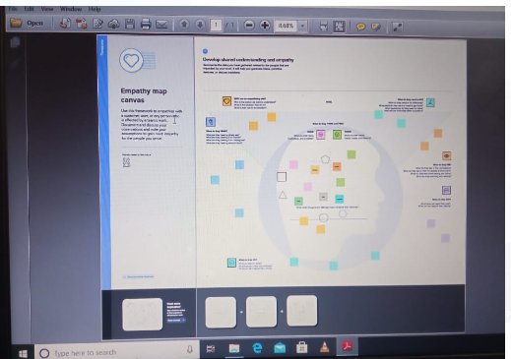

2.2 ideation and brainstorming map

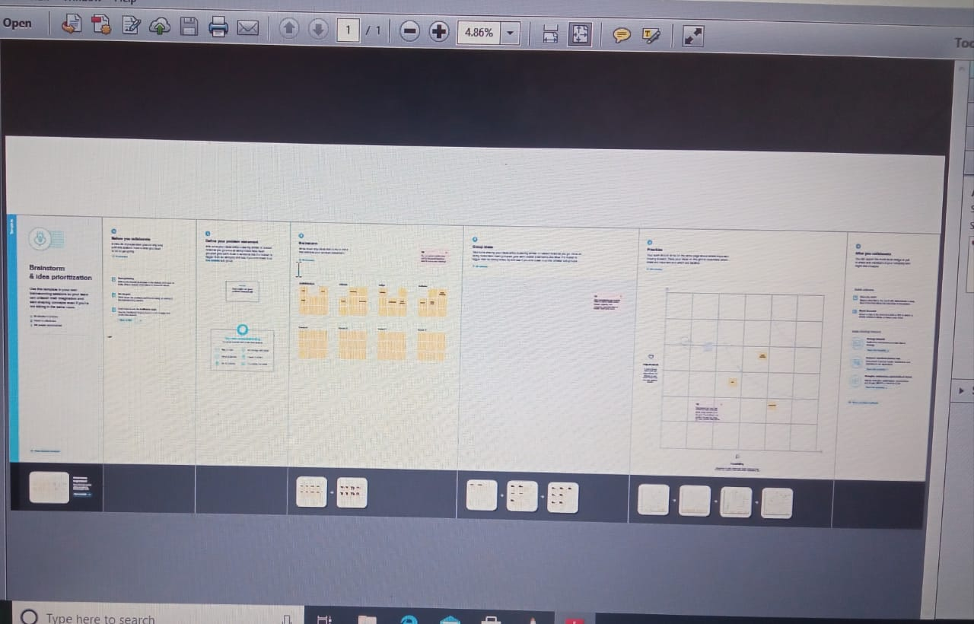

3. Result

3.1 Data Model:

|  |  |  |  |  |  |  |  |  |  |  |  |
| --- | --- | --- | --- | --- | --- | --- | --- | --- | --- | --- | --- |
| Event | |  |  | | --- | --- | | Field label | Data type | | Entre city | Text | | Entre phone | Phone | | Entre start | Time | | Entre start | Date | |
| Aettend | |  |  | | --- | --- | | Entre id | Number | | phone | Phone | | Entre email | Email | | Entre ticket | piciklist | |
| speaker | |  |  | | --- | --- | | Entre id | Mater degree detail | | Entre name | name | | Entre phone | Phone | |
| vendore | |  |  | | --- | --- | | email | Email | | phone | phone | | Entre name | Lockup | |

3.20 activity and screenshot

Activity 1 :

1. Creation developer accont
2. Account activation
3. Salesforce login

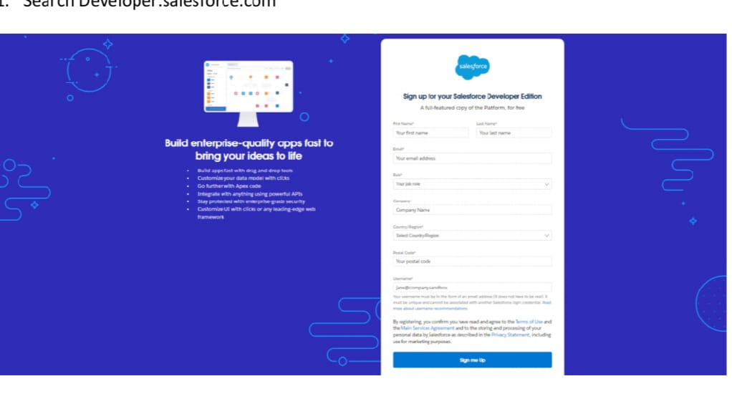

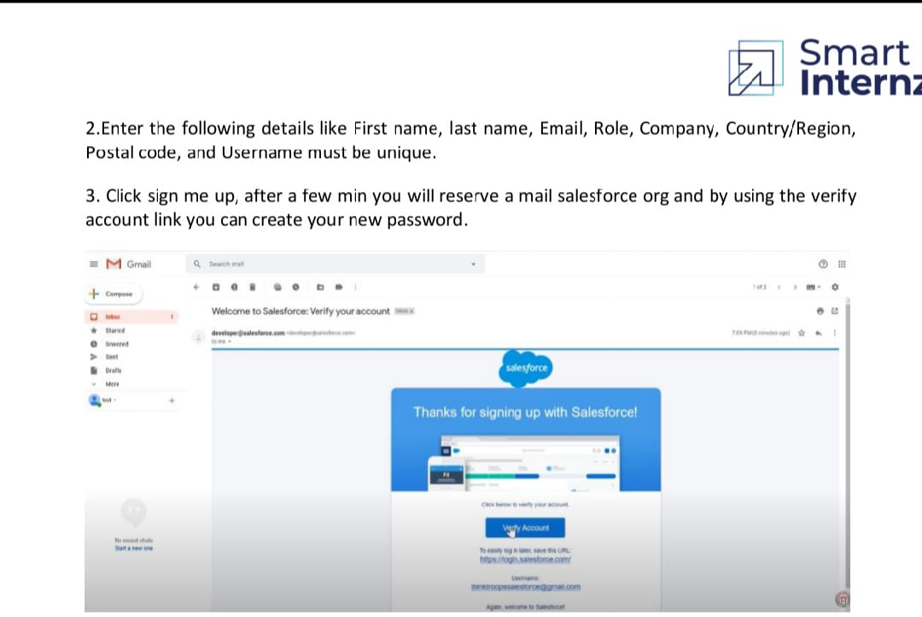

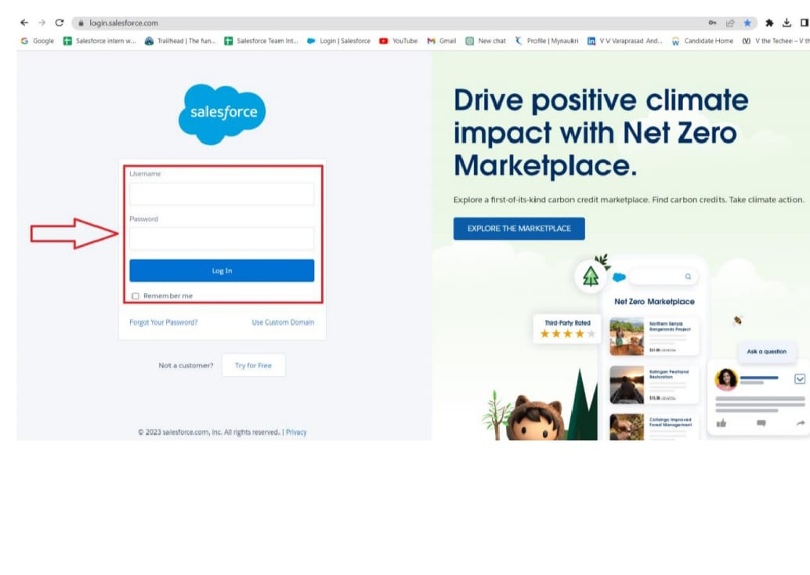

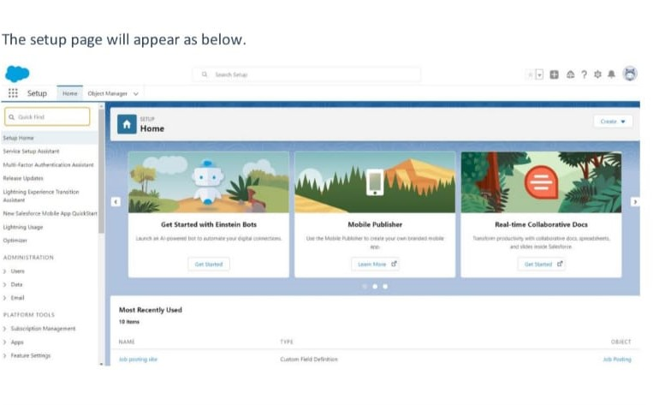

Milestone:



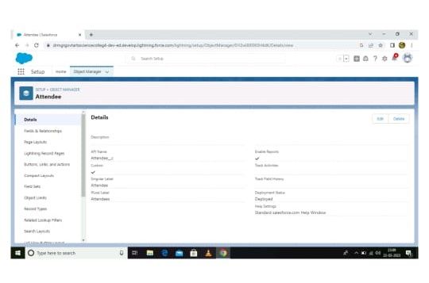

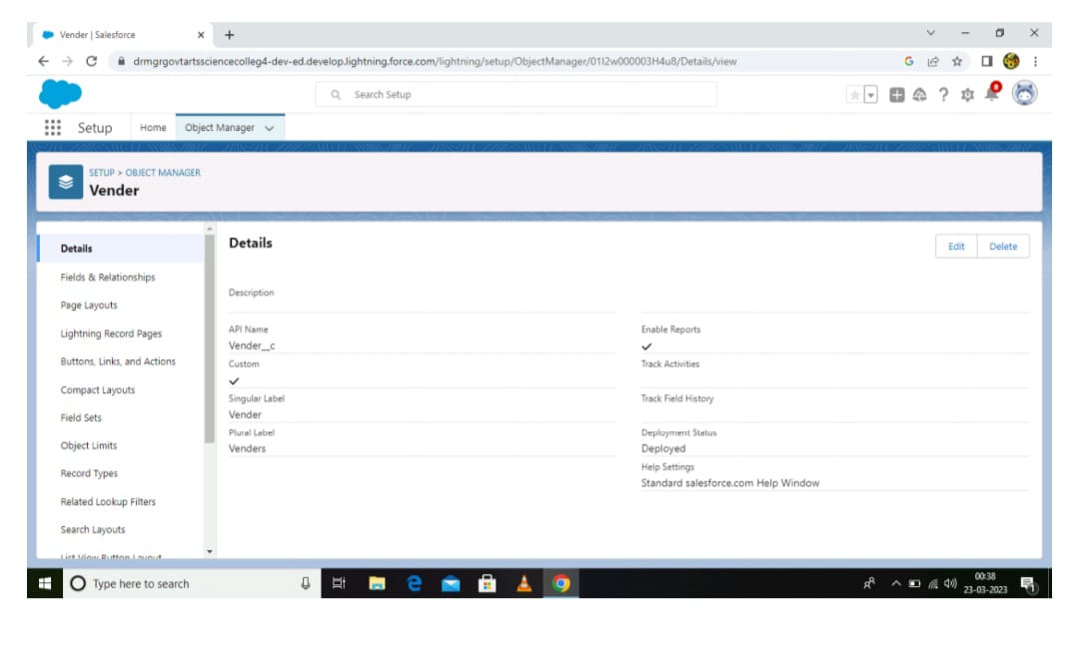

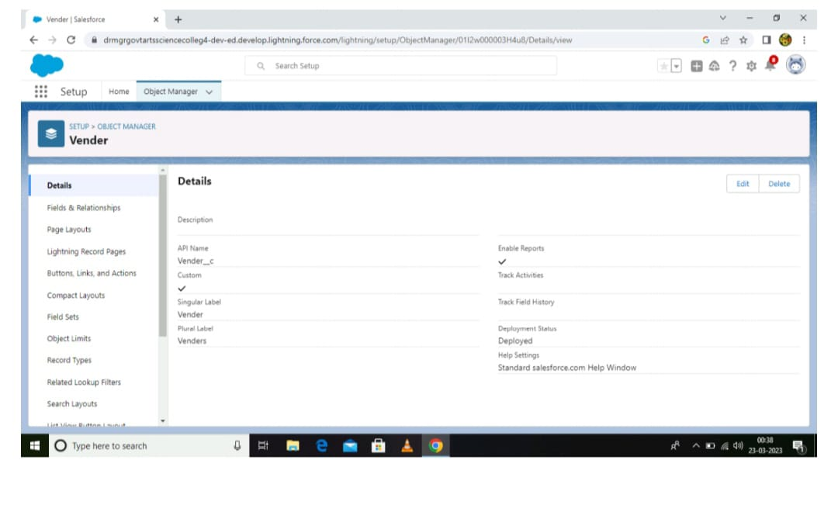

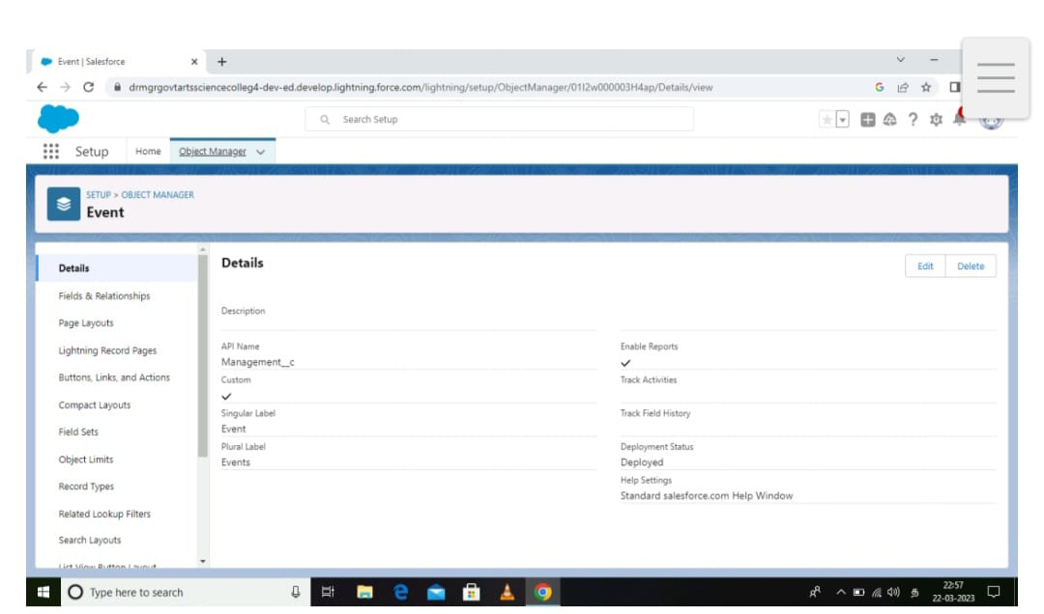

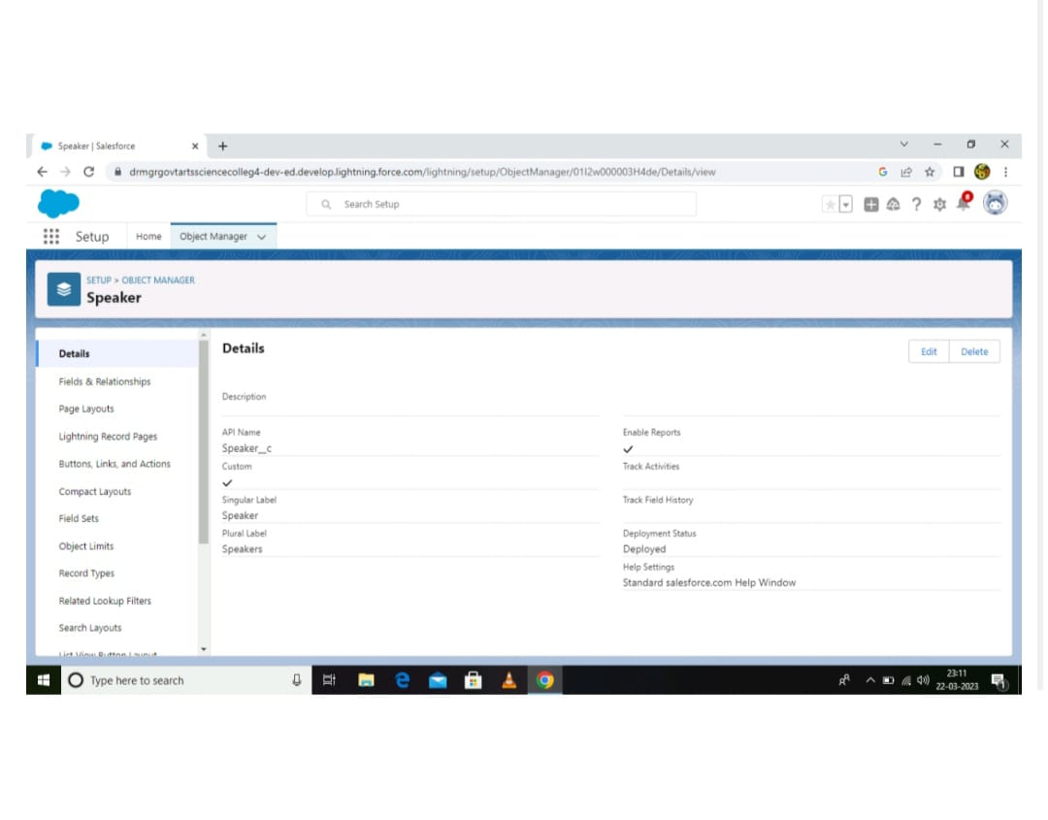

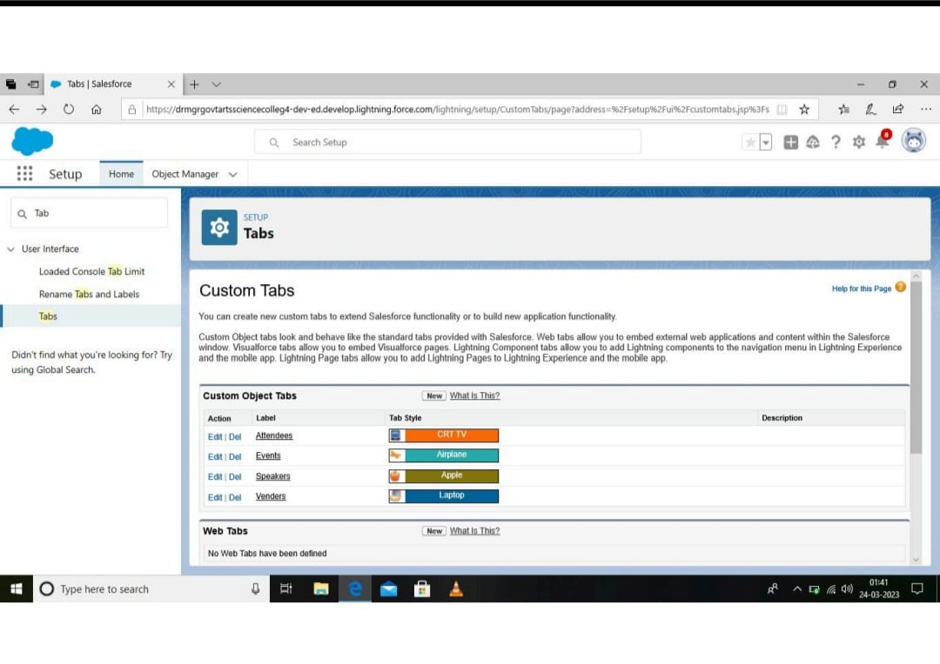

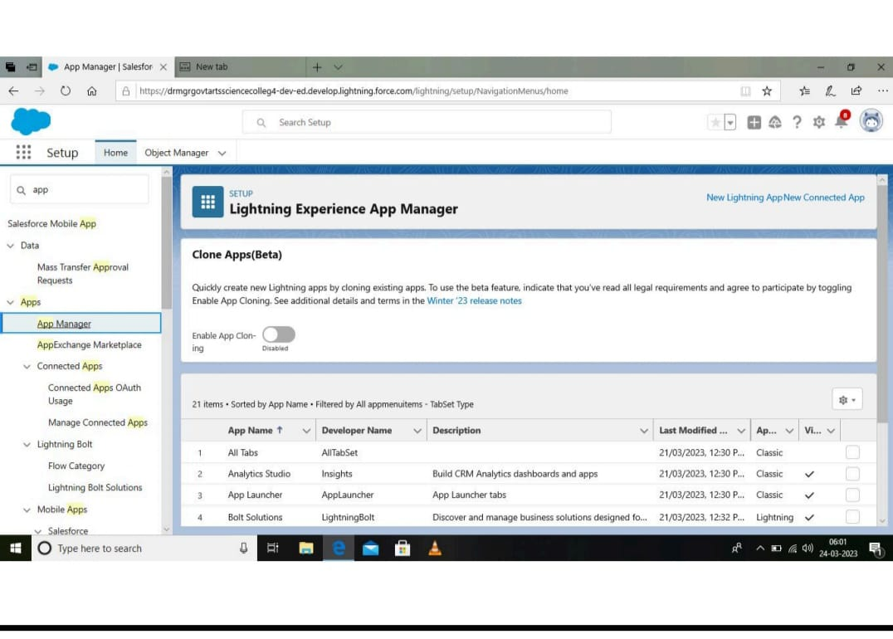

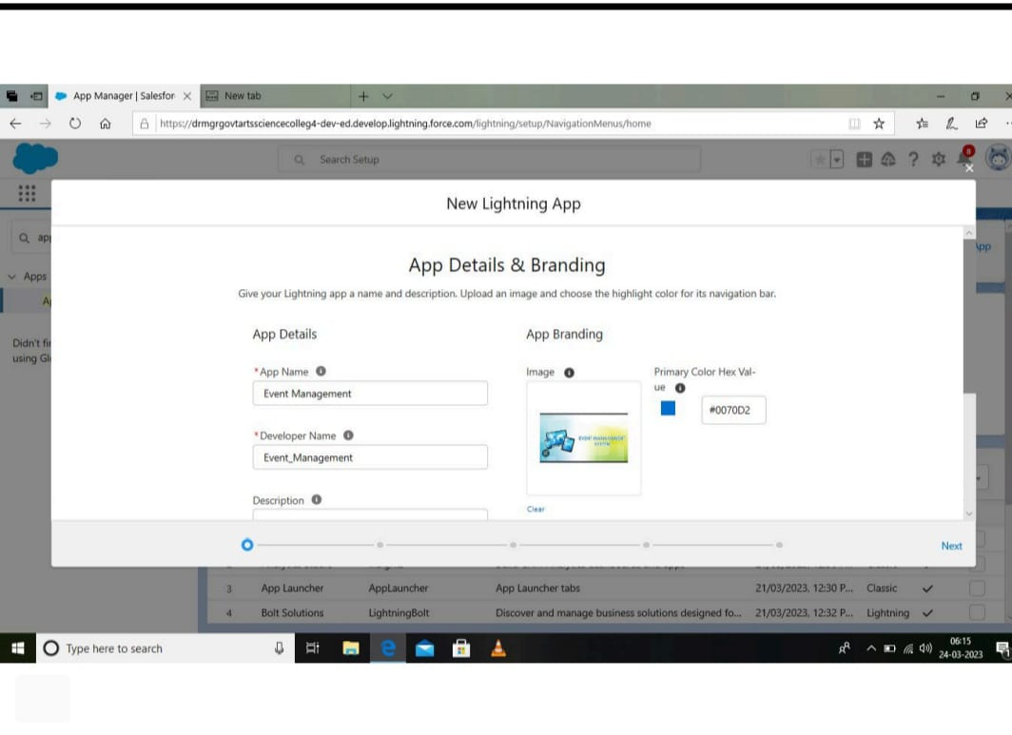

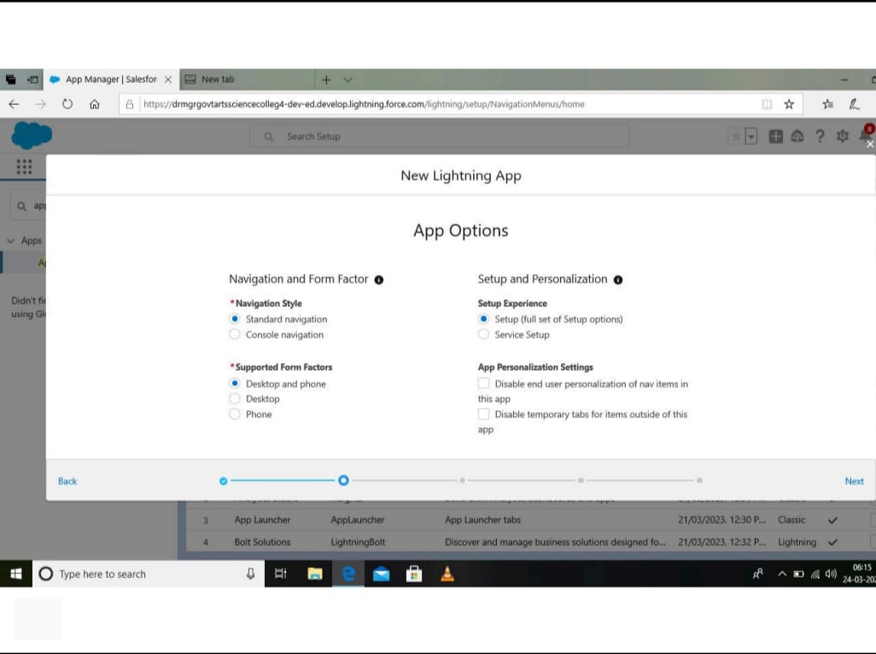

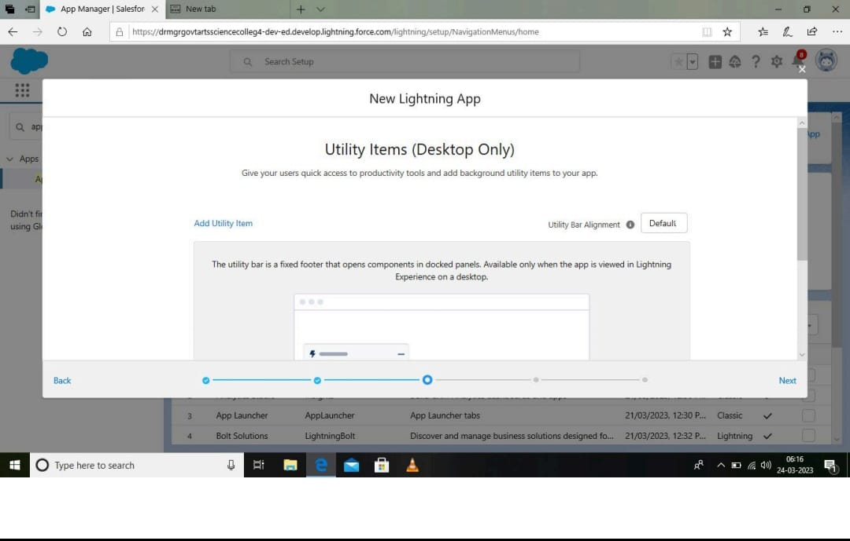

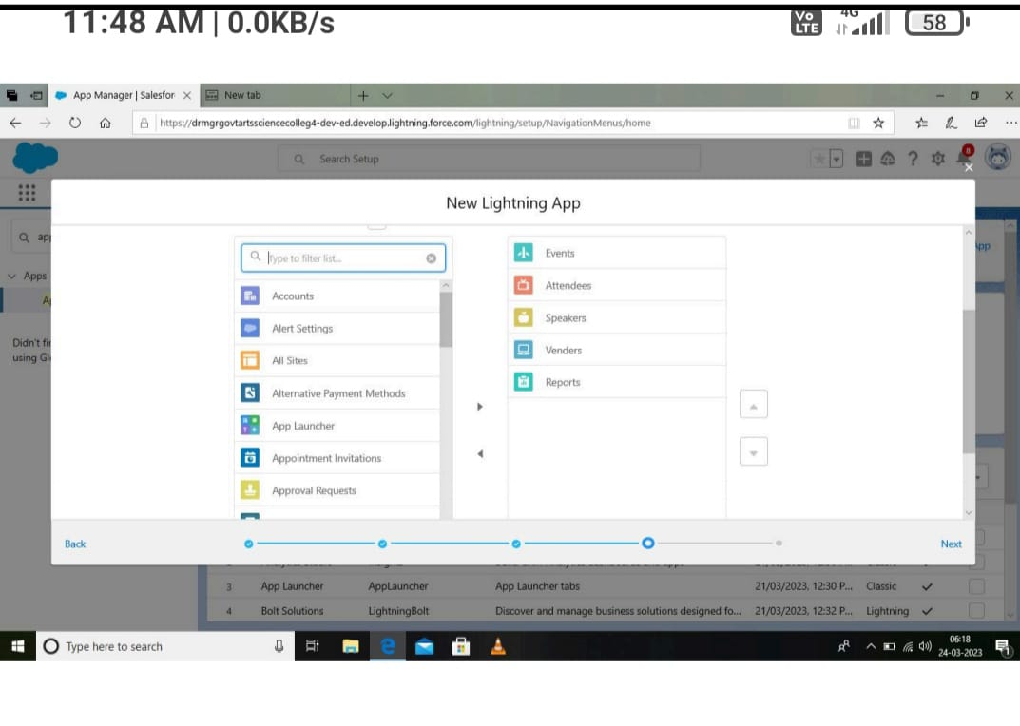

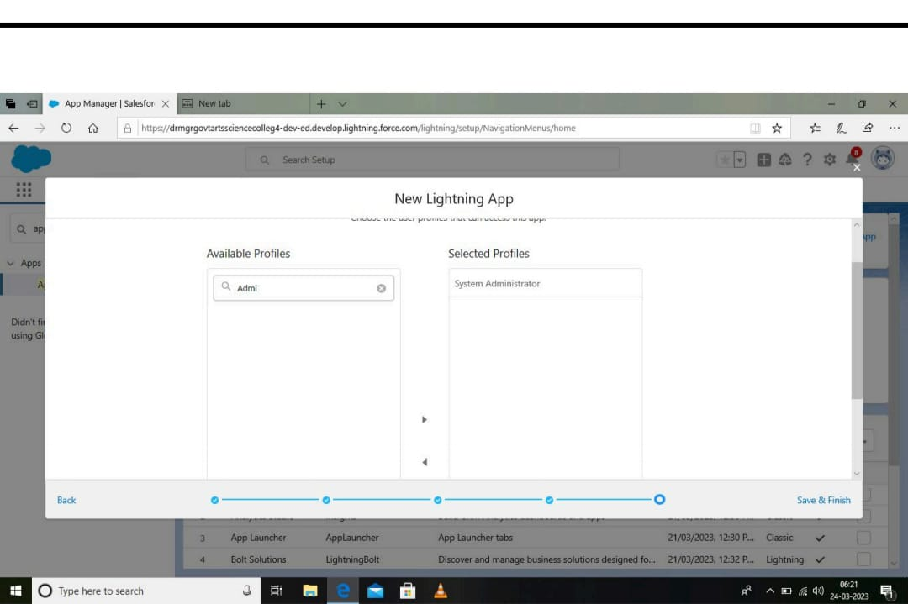

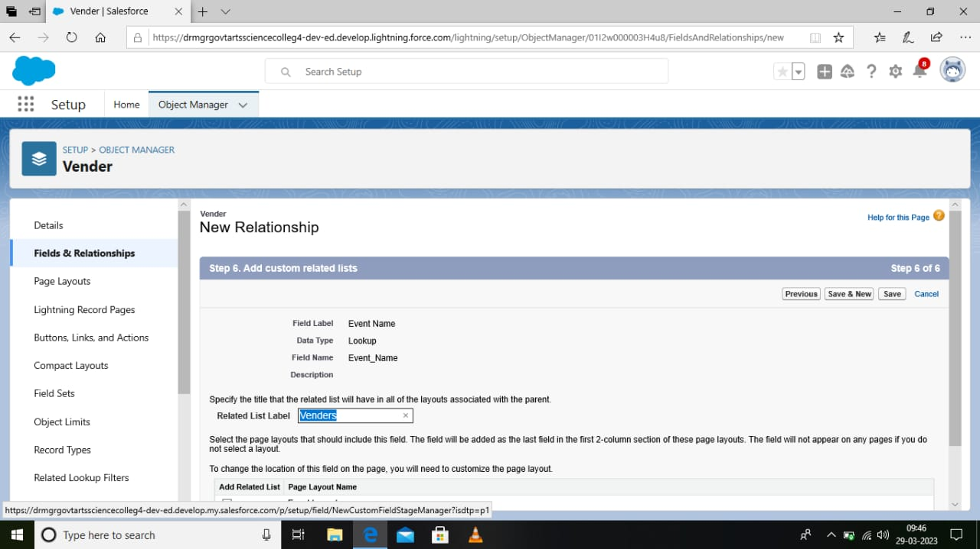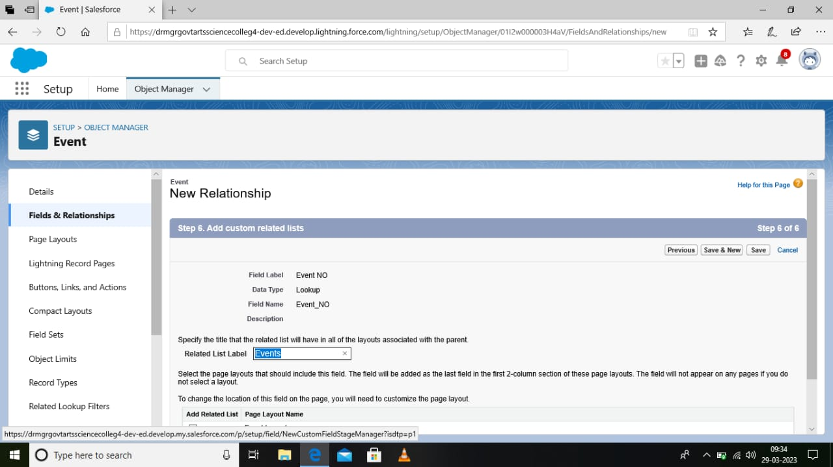

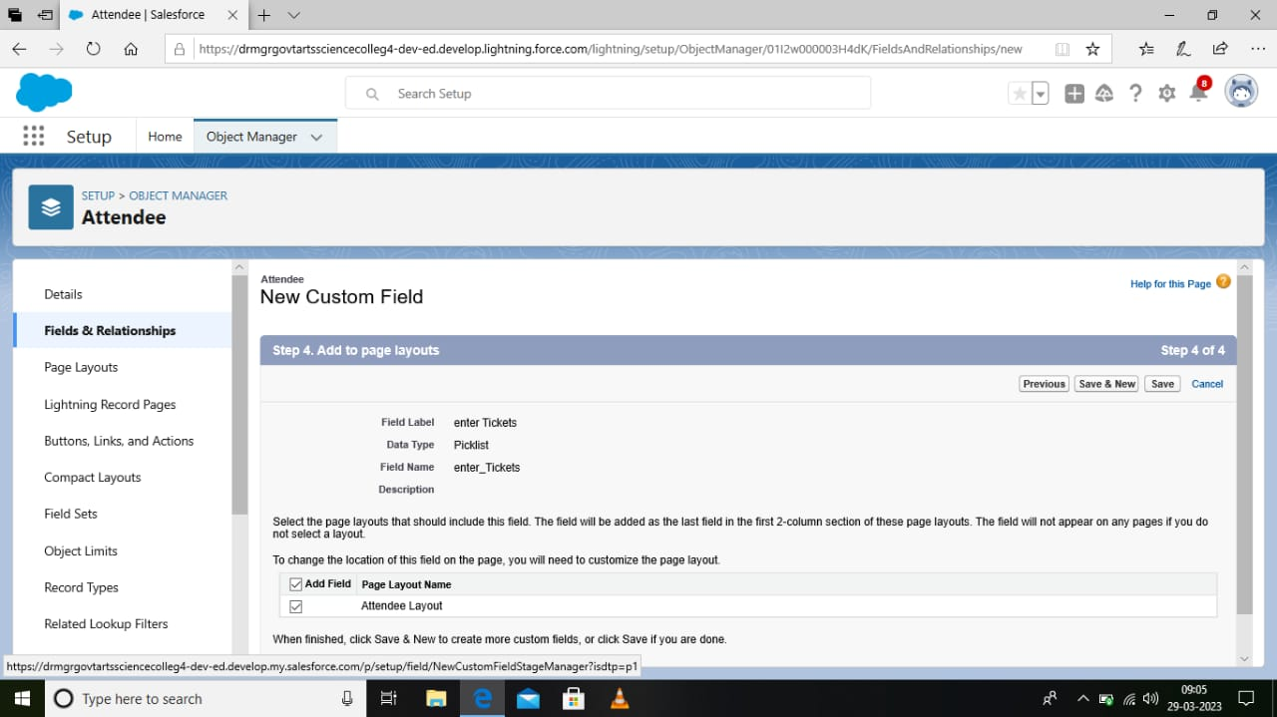

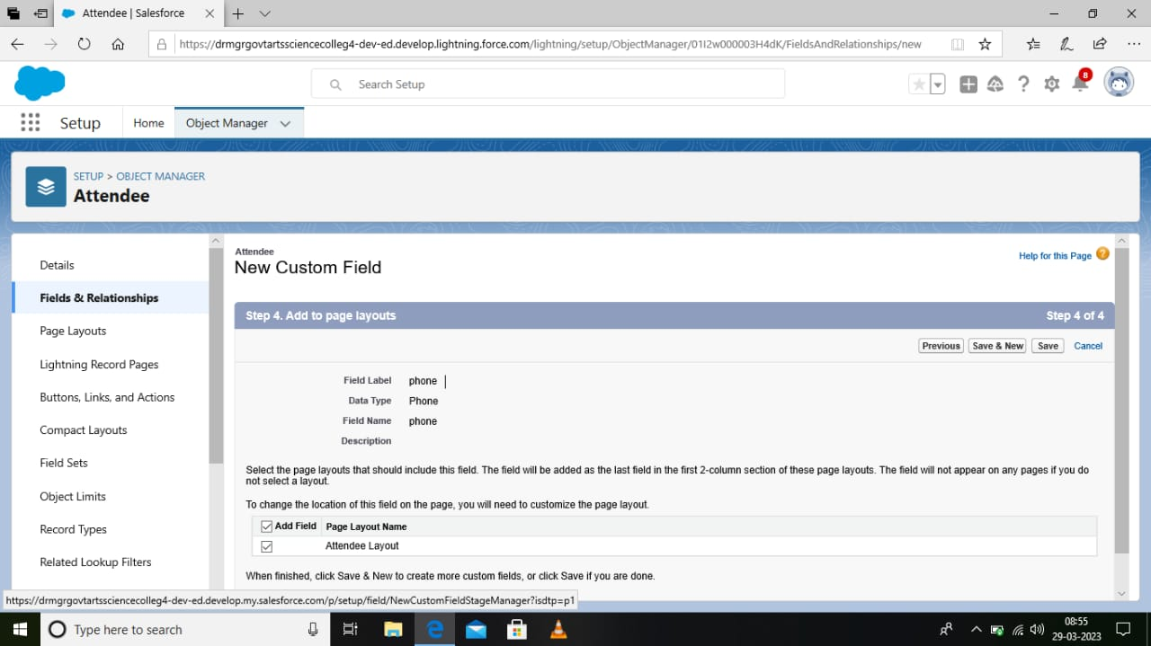

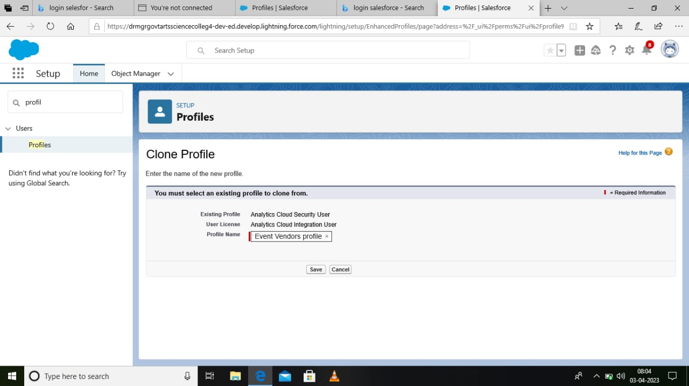

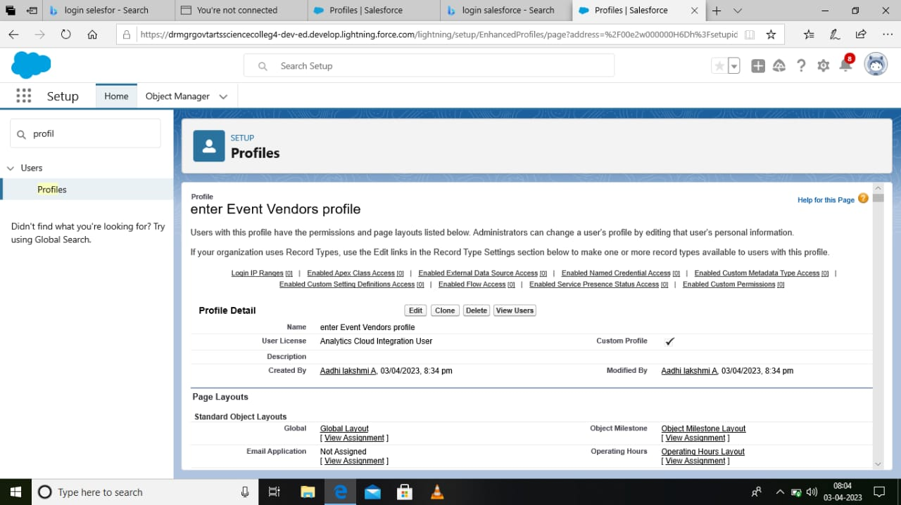

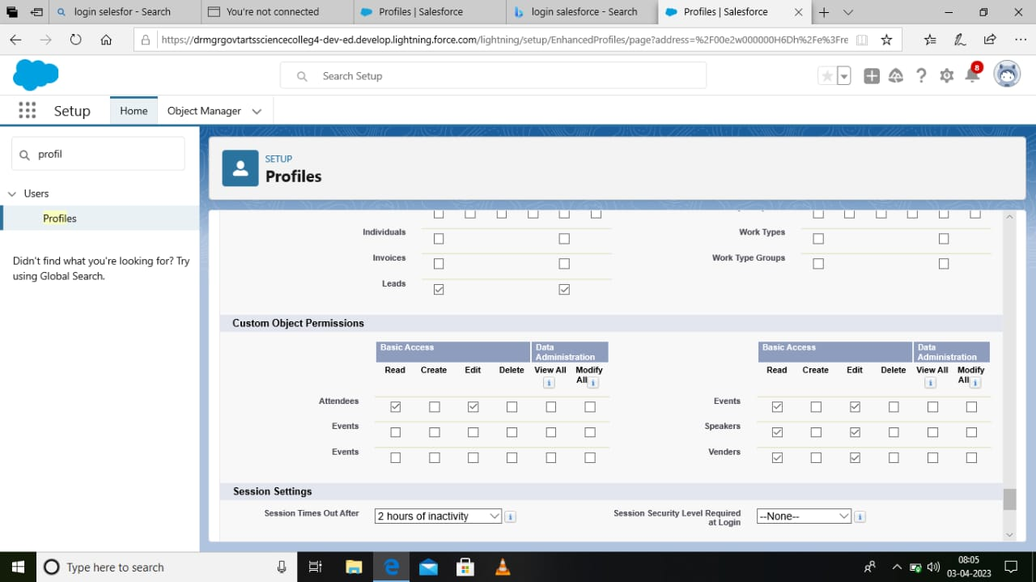

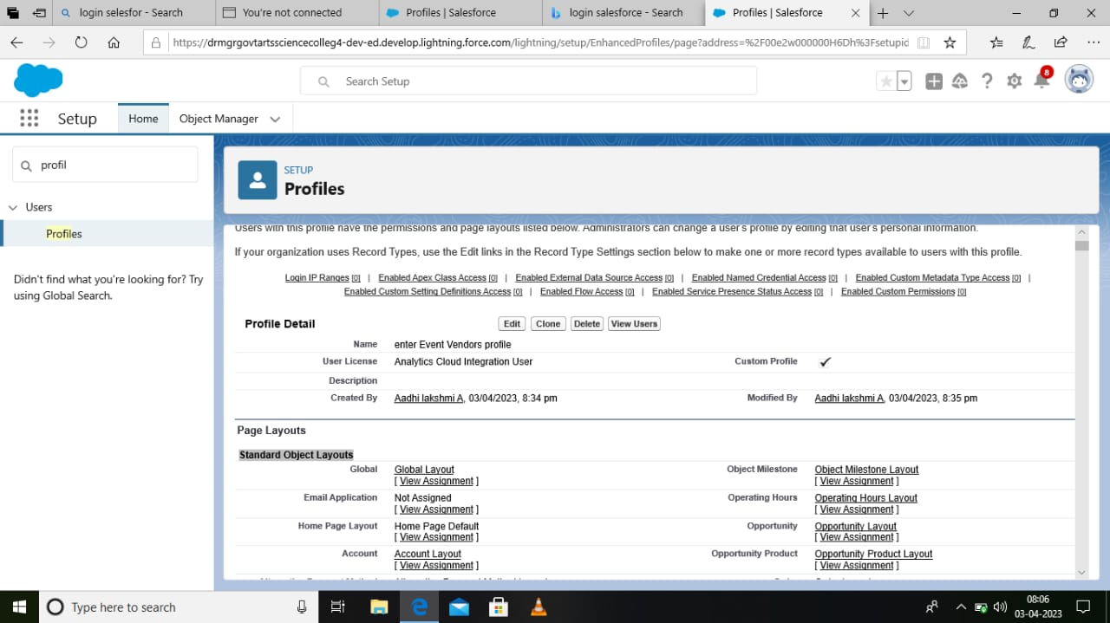

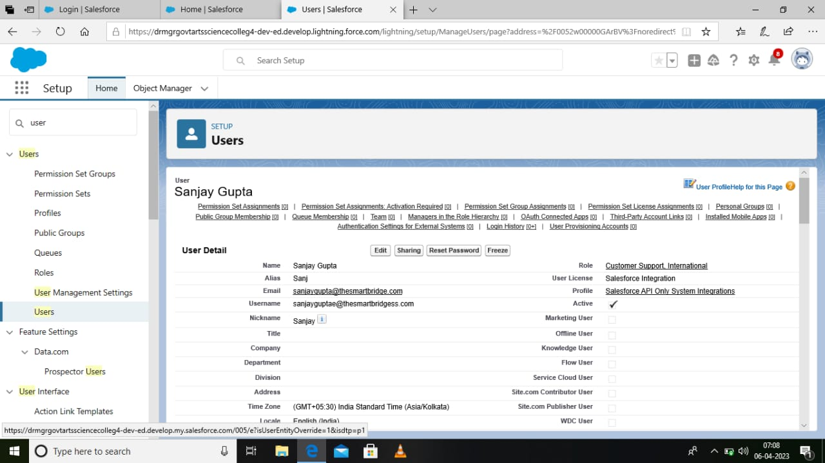

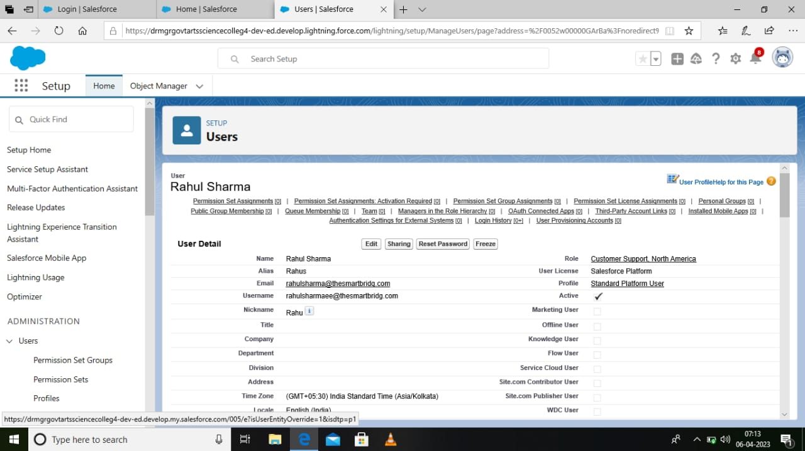







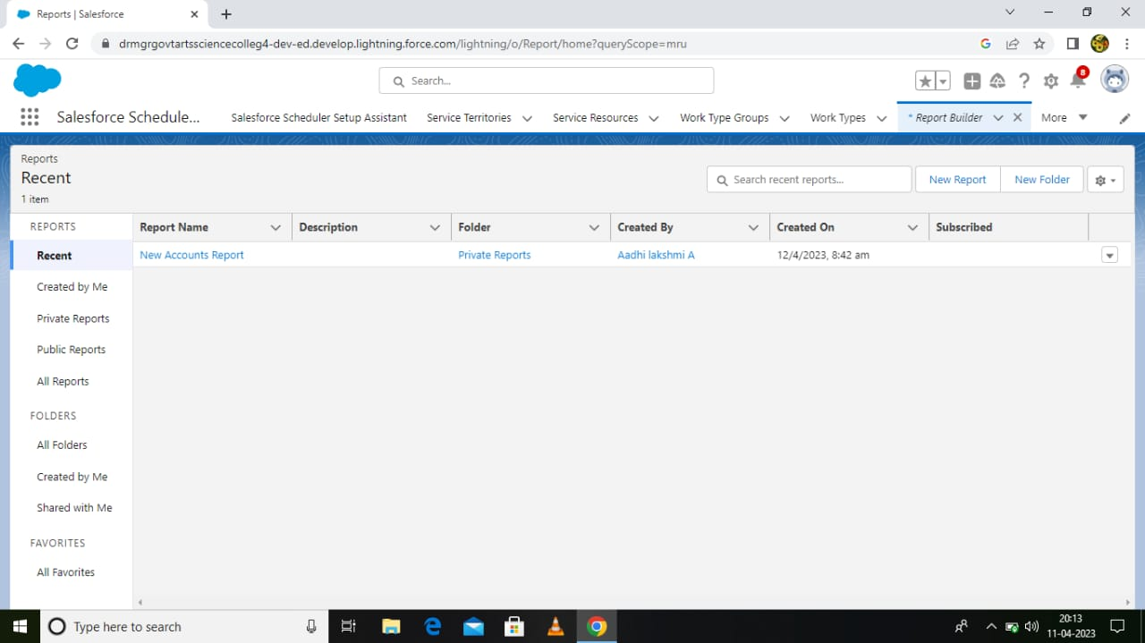



1. Trailhead profile public URL:

Team leader -<https://trailblazer.me/id/aaadhilakshmia>

Team member.1-<https://trailblazer.me/id/vvetri4>

Team member.2-<http://trailblazer.me/id/asubha29>

Team member.3-<https://trailblazer.me/id/abinv8>

1. Advantages :

* Opportunities for creativity. ...
* Ability to work on different events. ...
* Chance to work with diverse clients. ...
* Collaborative work environment. ...
* High projections for job growth.
* Few educational requirements. ...
* Unconventional work hours. ...
* Time away from family and friends.

Disadvantages:

Difficult to handle work manually. Time consuming process. More human power required

6.Application :

* They make it less stressful. It goes without saying that organising an event, no matter the type of size, it is going to be stressful. ...
* They ensure it runs smoothly. ...
* They take care of the legalities. ...
* They have the right contacts. ...
* Come and Talk to Us

Conclusion:

 Event Management System is **user friendly and cost effective system**, it is customized with activities related to event management life-cycle.

Future scope :

**Yes, it is**. The scope of event management as a career in India is vast. It's a thriving industry and is home to a million people. So, if you have a knack for creativity and

want to redesign the perceptions of society, the event management industry is all for you.

It involves **management, creation and development of events such as corporate conferences, wedding, festivities, formal parties etc**. It involves a lot of research about the brand, target audience and the concept of the event before planning the actual event